Proposal to ICD

Upon Block Chain Adoption

By

HLC Public Chain

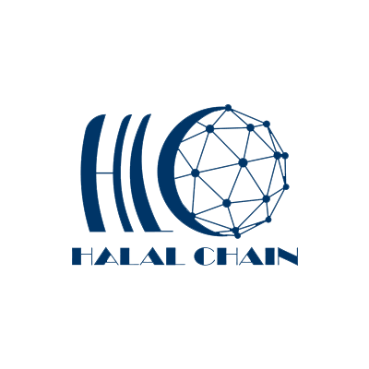

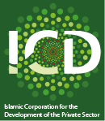

24th April 2019

* **1. About HLC Foundation (Halalchain)**

HalalChain is the first public blockchain company that focuses on serving Muslim countries and regions. By implementing blockchain technology into Islamic Financial Institutions and the Islamic economy ecosystem will help to increase trust, transparency and traceability in Islamic financial products and services, traceability of halal and healthy products, Smart Sukuk, Zakat application, Hajj chain, heritage and property registration, cultural communication etc. It is a great experience for HLC Foundation (Halalchain) to reshaping the Global Islamic economics ecosystem. And together with ICD will build a stable and robust Global Islamic economics with Blockchain technology.

However, HLC Technologies FZCO is commercial harm of HLC Foundation. HalalChain is built on the new distributed ledger Directed Acyclic Graph (DAG). This underlying technology, guarantees security and decentralization by achieving “High Throughput”. By combining the advanced DAG technology with unique application scenarios we are able to build across the multi-layer payment system within the Islamic economy ecosystem.

* **2. About ICD**

The Islamic Corporation for the Development of the Private Sector (ICD) is a multilateral development financial institution and is part of the Islamic Development Bank (IsDB) Group. ICD was established in November 1999 to support the economic development of its member countries through the provision of finance for private sector projects, promoting competition and entrepreneurship, providing advisory services to the governments and private companies and encouraging cross border investments.

ICD has an authorized capital of $4 billion. Currently, the shareholders of ICD are the IsDB, 54 Islamic countries and five public financial institutions.

ICD fosters sustainable economic growth in its 54 member countries by financing private sector investment, mobilizing capital in the international financial markets, and providing advisory services to business and governments. ICD financing projects are selected on the basis of their contribution to economic development considering factors such as job creation, Islamic finance development, contribution to exports etc. ICD also provides advisory services to governments and private sector groups on policies designed to encourage the establishment, expansion and modernization of private enterprises, development of capital markets, best management practices and to enhance the role of the market economy. ICD operates to complement the activities of the IsDB in member countries and also that of national financial institutions

* **3. Overview of the ICD proposal**

In the last century, the global financial system is primarily dominated by “wall street “model, which leads to a series of periodical and systematic financial crisis, until blockchain technology emerges, and acts as the fundamental driver to re-construct global economy, from financial order to many other aspects. The current global financial order is a passive acceptance to Islamic Finance, in spite of fundamental structure differences. Along the course of re-shaping the order or restyling as the term used for this event, that some underlying issues, challenges would be effectively constrained through the adoption of blockchain technology in Islamic Financial Institutions.

it is necessary to look at the main building block to enable trust in impersonal financial transactions in a highly globalized society. The HLC technology innovation called the “blockchain” will benefit the ICD and its network of eighty eight financial institutions and more than twelve leasing companies worldwide as well play a crucial role in boosting the Islamic financial sectors in all its segments which include banking, insurance, Capital market, Smart Zakah and Waqf chain management. Addressing the digital revolution that is happening right now will foster competitive advantage for the Islamic economy and finance industry.

A platform where community of like-minded financial entities seek to collaborate on business opportunities, exchanging market intelligence and laying a foundation for actual financial transactions within the OIC member countries and across borders.

One major goal of this online Platform is the sharing of investment, advisory, sukuk, financing and other deals in an environment of common Islamic values. However, HLC public chain platform will complement the ICD global platform for private sector. The HLC platform is based on advanced blockchain empower by Block DAG in order reshape the Global Islamic economy ecosystem, that will allow users and investors to easily engage in the trading their ecosystem tokens using various payment methods. HLC Foundation’s goal through its commercial will provide and promote the mass adoption of Blockchain technologies by becoming a globally trusted service provider in various segment of Islamic economy ecosystem. To this end, HLC have created a unique solutions with relevant regulatory compliances built into the products and services to be offered in Islamic economy ecosystem.

**Why HLC public chain platform**

BlockChain reduces the trust costs among multiple parties - no one needs to trust another party or through an intermediary. However, BlockChain is facing some challenges from technology perspective, which keep BlockChain into practical business scenarios. The HLC has solved these challenges base on the following

Scalability

When a blockchain is deemed scalable, it means that it could provides sufficient services as the demands grows. There seems to be a contradiction between scalalbility and security, to be more specific, decentralization. Bitcoin and Ethereum are fully decentralized BlockChain in theory, actually not due to mining pool though, but they could only process theoretically 7 and 15 transactions per second, which are far behind the expectation as a payment network. Ripple and Stellar claim thousands of transactions per second capability, however, they are generally considered as permissioned blockchains and rather centralized, that is to say, we need to trust block producers, which is a too strngent setting in various scenarios.

Why do we care decentralization so much?

Because decentralization is the source of trust on BlockChain. Simple question, how do we prevent the Denial-of-Service attacks if only a few servers serve the network? How to stop collusions if the network is controlled in a few hands?

Interoperability

There is no single project to rule the blockchain world. Bitcoin and Ethereum have different protocols, even there are solutions that could make them communicate with each other, they could not undertake such big amount of services per se, what's more, the are designed to live with its own ecosystem. So we need a blockchain born with embracing other blockchain ecosystem, meaning easy to be interacted with.

Compliance

Currently, there is no blockchain compliant with Islamic laws because they are not built to serve Muslims. So, how to trust a Decentrailized App claiming there are providing Halal food, how to regulate pornographic services? In addition, how to avoid people live with interets?

How does HLC to accept those challenges

Halal Chain (HLC) is the first blockchain to serve Islamic finance, built by Islamic finacial experts as well as experience blockchain developers. So HLC know what a real Islamic public blockchian would be like and gives its own solution.

Block DAG to solve scalability

Block DAG is probablily the only sacability solution so far to comply with the classic blockchain setting, i.e., fully decentralized, 50% fault tolerance, high throughput. When the throughput is high, there will be multiple blocks created in parrallel, according to longest-chain rule consensus as most blockchain networks do, competing blocks will increase proabablity of forks and cause security issues. On ther contratry, Block DAG is using heaviest-chain rule consensus to embrace those forks while keeping the same security as bitcoin - 50% fault tolerance.

Born with interoperability

One of the HLC core code is to embrace various ecosystems and help their the values flow among each other. So, HLC has inverstigated the state-of-art interoperbility solutions, such as PolkaDot and Cosmos, dedicated to provide a best practice to integrate mainstream blockchain worlds, like bitcoin and Ethereum.

Regulations according to Islamic Law

The most HLC innovative contribution to Islamic finance is the tokenization mechanism. Other than other assets issuance platform without any regulation, HLC require organizations to hold a special token called licenses to issue their assets or tokens. Those licenses are distributed from authorized Islamic finance experts and all the disrtibutions can be tracked on the blockchain, so it is unlikely for a license to be distributed to a wrong hand.

For the sake of assets security, as well as huge volumes of transactions involves in the complete ecosystem, an excellent underlying protocol should be properly selected and specified along the way to undertake such massive industry adoptions. Security, scalability, high throughput and Shariah consideration should be appropriately addressed when it comes to selection

**Our solution**

We hereby propose ICD to co-develop this public chain together with foundation, then ICD will promote adoption of HLC public chain among the OIC member countries. This will help and facilitate the members countries to use standard protocol in their cross boarder and Exchanging market trading and multilayer payment system for actual financial transactions within the ICD member countries and beyond. The HLC Foundation is hereby looking forward the ICD is to be its partner in adopting HLC public chain platform, so these applicable use cases will add value to ICD revenue and it will benefit ICD member countries.

**How to develop Islamic finance based on blockchain?**

The Islamic economy’s full potential could be fully unleashed through blockchain, which could enhance the stability, security and public participation of the new financial landscape in modern era. The ultimate approach is to activate global Islamic assets and attract liquidity through the organic combination of Islamic economy and blockchain which could be illustrated in form of applicable use cases on the HLC public chain:

**Case one: Smart Sukuk**

The main industry trend in the blockchain and Islamic Economy is to set up the relationship mapping between physical asset and Crypto-asset, which gives Islamic finance an opportunity to act as the global platform for Islamic Asset tokenization. Such platform (HLC platform) would attract trillions size of assets to be tokenized through blockchain.

Smart Sukuk is a tokenization by collecting funds from investors in exchange for Sukuk Tokens which representing an ownership portion of the Sukuk investment. When the institutions (SPE) makes payments, the funds are automatically distributed back to the Sukuk Token holders via the blockchain according to the rules of the smart contract in Islamic Economics - without the need of intermediaries.

Smart Sukuk based on blockchain, would solve the bottlenecks in the course of Issuance, subscription, operation, governance, regulation and circulation in the industry. A tokenized, divisible, and tradable Sukuk asset could provide access to liquidity pool from the public as well as the global crypto-market.

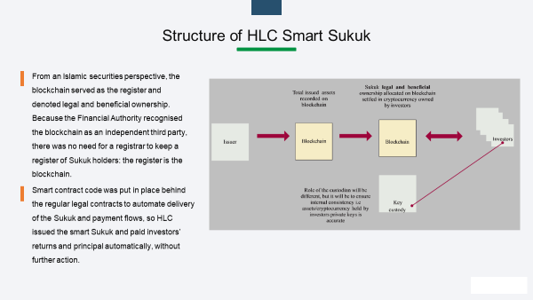

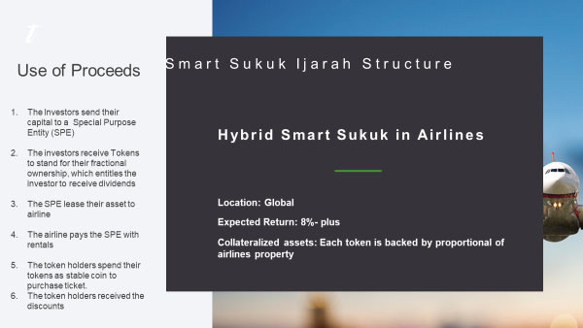Fig

As shown above, airplane could be tokenized via blockchain, the token stands for the fractional ownership of the physical asset, which gives the confidence and guarantee to the investors. In addition, such token could also be used as means of payment to purchase tickets, through such ecosystem, the operator, consumer, and investors formulates an internal recycling ecosystem. The laid-up capital/idle fund in the society would be comprehensively activated, and effectively placed to incentivize the real economy development. The investment bubbles would be significantly constrained in compliance with Islamic Finance rules and principles. The Tokenization of Islamic Economy and Finance via blockchain would create a new economic growth.

**Case two: Stable coins**

**Stable coins**: is core product which is Shariah compliant smart contract that represents an equity stake in Sukuk portfolio, which successfully combines traditional Islamic finance principles with those of mainstream finance.

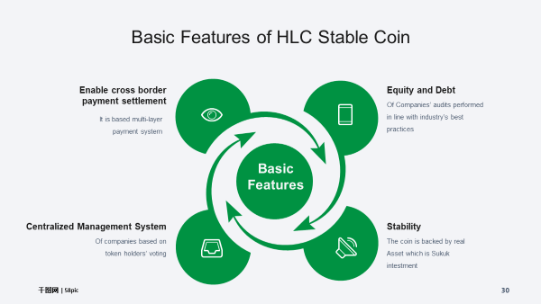

Stable Coin is a token whose smart contract represents the owners’ share in a financial fund formed by investment grade Sukuk. When consumers purchase the token, they are buying in to a fund of diversified Sukuk of high quality and high liquidity Sukuk.

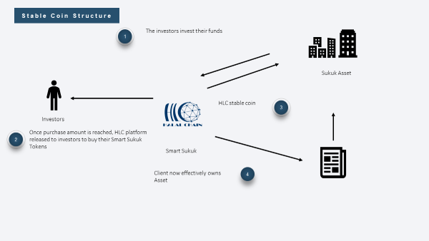

**Conclusion**

HLC Foundation , as a DAG based basic chain, with its significant technical attributes in the area of underlying security and high throughput, would be used as the technical platform to accommodate all the applications, as well as acting as the multi-layers payment and settlement system. The basic chain has been uniquely designed and developed aligning with Islamic finance principles from its technical consensus, community governance mechanism, ecosystem incentives to industry applications.

Therefore, ICD global platform for private sector should play the leading role to set up this platform the world has experienced half a decade of mainstream Blockchain applicable use cases, and HLC are at the verge of starting the mature enterprise blockchain era. A major strength of all Blockchain solutions revolves around their promising impact on a global financial scale. Within this context, HLC strongly believe that Blockchain solutions in the global Islamic economy ecosystem which are compliant with the Shariah regulatory or enterprise technology by consumers, investors, and entrepreneurs, and as such HLC is offering a flexible platform to the Islamic economy ecosystem.